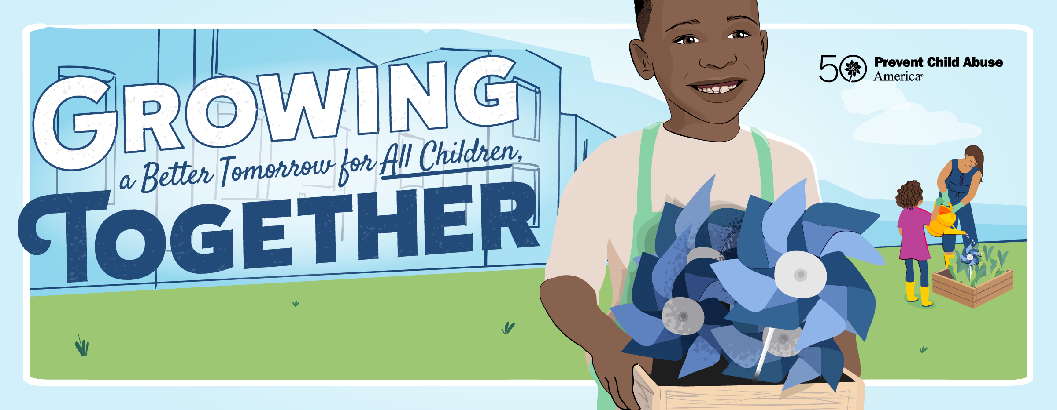
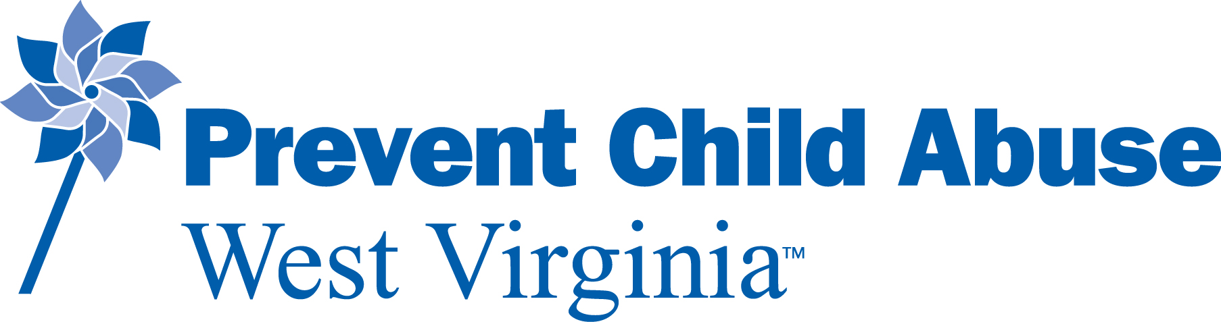

Child Abuse Prevention Month Activities 2022
Sunday | Monday | Tuesday | Wednesday | Thursday | Friday | Saturday
 |  |  |  |  | 1 | 2
 |  |  |  |  | Statewide  Wear Blue Day!  Cabell Co- Pinwheel planting at Children’s Home Society  Gilmer Co- Proclamation with County Commission; pinwheel gardens at Courthouse, City Park, etc.  Mineral Co- Wear Blue Challenge for local businesses  Raleigh Co- Pinwheel planting at Mayor Rappold’s Office & Just For Kids Office  Taylor Co- Flag Raising Ceremony; Ice Cream Social | Week of the Young Child (April 2-8)  Gilmer Co- Community Flea Market with pinwheels, goodies and activities  Mineral Co- Annual Paint the Town Blue  Pendleton Co- Paint the Town Blue Event  Pleasants Co- County-wide planting of pinwheel gardens
3 | 4 | 5 | 6 | 7 | 8 | 9
 | Gilmer Co- Gilmer Elementary pinwheel crafts for Week of the Young Child  Mingo Co- Flag raising and pinwheel garden at WH Compton Park in Delbarton; Flag raising and pinwheel garden at flag pole across from Western Auto in Kermit  Upshur Co- City Proclamation; Flag raising and pinwheels at Stockert Youth Center | Gilmer Co- Gilmer Elementary pinwheel crafts for Week of the Young Child  Marshall & Ohio Co- ‘Safe, Supported & Strong: Mandated Reporting in WV’ Training in Wheeling  Mingo Co- Flag raising and pinwheel garden at Larry Joe Harless Center in Gilbert; Flag raising and pinwheel garden at Town Hall in Matewan | Gilmer Co- Gilmer Elementary pinwheel crafts for Week of the Young Child  Marshall Co- Children at the Courthouse Event  Mineral Co- National Walk Day for Prevention & Family Night at Brookedale Farm  Mingo Co- CAP Awareness Walk in Williamson; Flag raising and pinwheel garden at Courthouse  Pleasants Co- Governor’s Proclamation at County Commission and City Council  Randolph Co- Flag Raising  Ritchie Co- Resource bag & pinwheel distribution at Packs of Plenty weekend feeding program | Gilmer Co- Gilmer Elementary pinwheel crafts for Week of the Young Child  Upshur Co- Flag raising with proclamation at Upshur Co Courthouse | Ohio Co- Wear Blue in Ohio County Schools | Monongalia Co- Literacy Event at Mountainview Elementary School  Preston Co- Easter Egg Hunt at Rowlesburg Park
10 | 11 | 12  Pleasants Co- Governor’s Proclamation at County Commission and City Council | 13  Mineral Co- Take Back Day at Fort Ashby Community Center; Coffee with CASA at Queen’s Point Coffee Shop | 14  Ritchie Co- Plant pinwheel garden at county courthouse | 15  Wetzel Co- Family Fun Night Skating Party | 16  Pleasants Co- Family Movie Night  Pocahontas Co- Easter Egg Hunt at Stillwell Park in Marlinton  WEaster Fun Hike at Beckley Youth Museum
Raleigh Co- JFK Easter Fun Hike at Beckley Youth Museum

Wetzel Co- Community Baby Safety Shower
17  Pleasants Co- Easter Bunny Drive-by in St. Mary’s | 18  Pleasants Co- CAP Awareness Walk in conjunction with SMHS Track Meet | 19  Upshur Co- Strawberry Festival Junior Royalty Parade | 20  Ritchie Co- Resource bag & pinwheel distribution at Packs of Plenty weekend feeding program  Wyoming Co- Baileysville SADD Chapter Wear Blue Day; pinwheel planting at the school | 21 | 22  Monongalia Co- Flag Raising Ceremony at WVU Ogleby Hall  Ohio Co- Deborah Doleski Allen Champion of Children Awards  Raleigh Co- Champions of Children GALA at Tamarack | 23  Monongalia Co- Outdoor Literacy Event at CAC
24 | 25  Monongalia & Pleasants Co- ACES 101 Webinar  Ohio Co- The Bright Side (live stream event)  Ritchie Co- Community Baby Shower | 26  Gilmer Co- Open House at Children’s Home Society | 27  Monongalia Co- ACES 102 Webinar | 28  Fayette Co- Bubble Release Ceremony  Monongalia Co-Walk Event at WVU Mountain Lair  Pleasants Co- Flag Raising at Courthouse; Ceremony of Life Celebration with presentation & release of butterflies  Ritchie Co- Celebration of Life Ceremony at Courthouse | 29  Kanawha Co- Plant pinwheel gardens at Sharon Dawes Elementary School  Mineral Co- Children’s Flag Day at the Courthouse  Monongalia Co- ACES 103 Webinar  Taylor Co- Family Movie Event  Ritchie Co- Teen Issues Day at Ritchie County High School | 30  Kanawha Co- Carnival at Sharon Dawes Elementary School  Pleasants Co- City Park Display in Parkersburg; Drug Take Back Day

Ongoing Events throughout the month:

- Cabell Co- Unveiling of “12 Affirmations for Happy Family” awareness and education campaign throughout the month of April. Family starter packets will be provided to Children’s Home Society and Lily’s Place.
- Gilmer Co- Pinwheel crafts from Gilmer Elementary will be on display at the FRN office and Foodland on April 20th and 23rd.
- Mineral Co- Wear Blue Day every Friday in April; Pinwheel garden plantings.
- Mingo Co- Pinwheel gardens will be planed at Head Start centers in Mingo and McDowell Counties, and other locations throughout the county.
- Pendleton Co- Brandywine Elementary students will plant pinwheels and banners.
- Pleasants Co- Flag raising ceremonies and coloring contests will take place at each elementary school during Week of the Young Child (April 2-8)
- Raleigh Co- Hosting an art competition with Fayette County during April & May; the Art Theme is SHINE.
- Ritchie Co- Teen Issues Day at Ritchie County High School will include speakers discussing healthy decisions, suicide intervention, bullying, DUI simulator, dealing with loss, yoga/breathing, recovery, etc.
- Webster Co- Pinwheel display contest with Webster Springs Elementary and Glade Elementary
- Wyoming Co- Distributing “Blue Bags” for kids and families; decorating all schools and other areas with pinwheels. Courthouse Lawn Event date TBD.
- Upshur Co- Children’s book readings on Facebook page; Coloring Contest at Stockert Youth Center; Pinwheel plantings at Courthouse and other locations around the county.

