Circle of Parents is a national network of parent-led groups, where parents and caregivers share ideas, celebrate successes and address the challenges surrounding parenting. TEAM for WV Children launched Circle of Parents in West Virginia in September 2012 by training facilitators from five organizations. The network has grown to over 30 sponsoring organizations and has trained more than 100 facilitators and parent leaders, thanks to funding from the Claude Worthington Benedum Foundation and WV Department of Health and Human Resources. The map below represents WV counties that make up the WV Circle of Parents Network. Counties highlighted in blue have reported active Circle of Parents groups from July 2019- Current. Contact information for those groups is listed as well. For a list of current sponsoring organizations or more information on the Circle of Parents Network please visit http://www.teamwv.org/circle-of-parents/ or contact LaCrisha Rose: lacrisha@teamwv.org (304) 410-5888

Marti Hendricks: (Boone and Lincoln Co.)  Cornerstone Family Interventions  Martihendricks@cfiwv.org | Dayla Harvey: (Mineral Co)  Mineral Co FRN  Mineralfamilyresourcenetwork@gmail.com
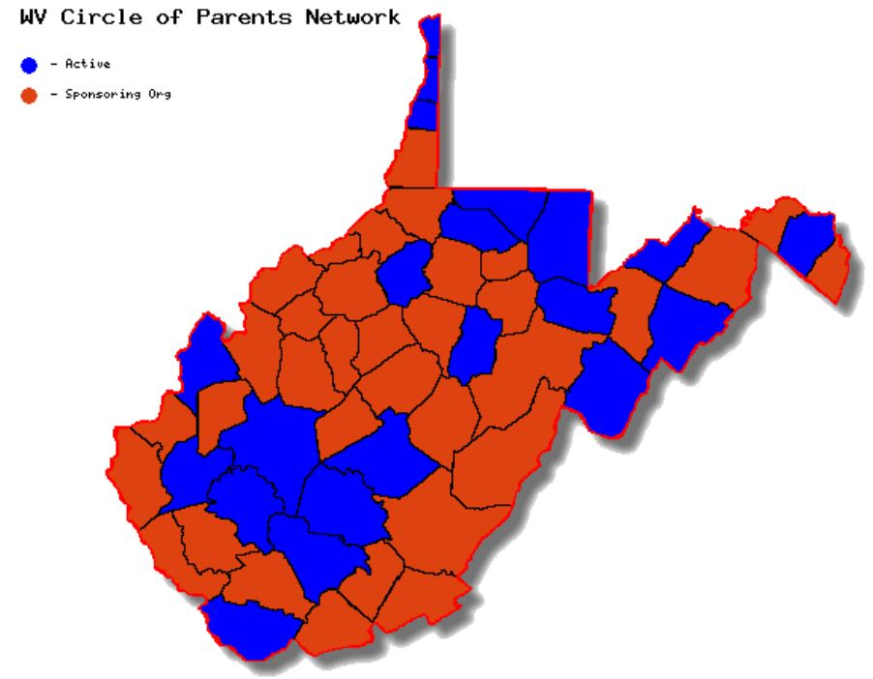  Lori Ulderich: (Upshur Co)  Upshur Co FRN  upshurfrn@yahoo.com | Sandra Bohon: (Preston Co)  Preston Co FRN  sandrabohon@yahoo.com
Taralyn Gwinn: (Fayette Co)  New River Health-MIHOW  taralyn.mihow@gmail.com | Claudia Raymer; (Ohio Co)  Ohio Co FRN=SNAPS  OhioCountyFRN@yahoo.com
Olivia Gregorich: (Lincoln Co)  Mountain State Healthy Families  olivia@teamwv.org  Stephanie Fitzwater: (Tucker Co)  Foster Together Adopt Forever  js.fitzwater@hotmail.com | Alex Smith: (Kanawha Co)  RFRN UKVSP=Sharon Dawes Elem  allie.smith09@hotmail.com  Kara Ramsey: (Nicholas Co)  MHCS- WV Birth to Three Region 6  kramsey@mthtwv.org
Tammy Rogers: (Mason Co)  MSHF=Scrapbooking/Craft  tammy@teamwv.org | Lori Heginbotham: (All 55 Counties)  WVU Centers for Excellence & Diabilities  lori.heginbotham@hsc.wvu.edu
Melody Brown: (Doddridge Co)  Doddridge Co SPFRC  dcspc1@frontier.com | Stacie Boggess: (Kanawha Co)  Zion Child Development Center  sabtksb@gmail.com
Valerie Smith (Kanawha Co)  EBMS Circle of Friends  val_holley@yahoo.com | Rita Hawkins: (Brooke and Hancock Co)  Brooke Hancock FRN: Special Needs  rhawkins@brookehancockfrn.org
Tammy Fleshman; (Raleigh and McDowell Co)
MHCS= Adoptive/Foster, Grandparents, Moms, Turning Point
tfleshman@mountainheartwv.org

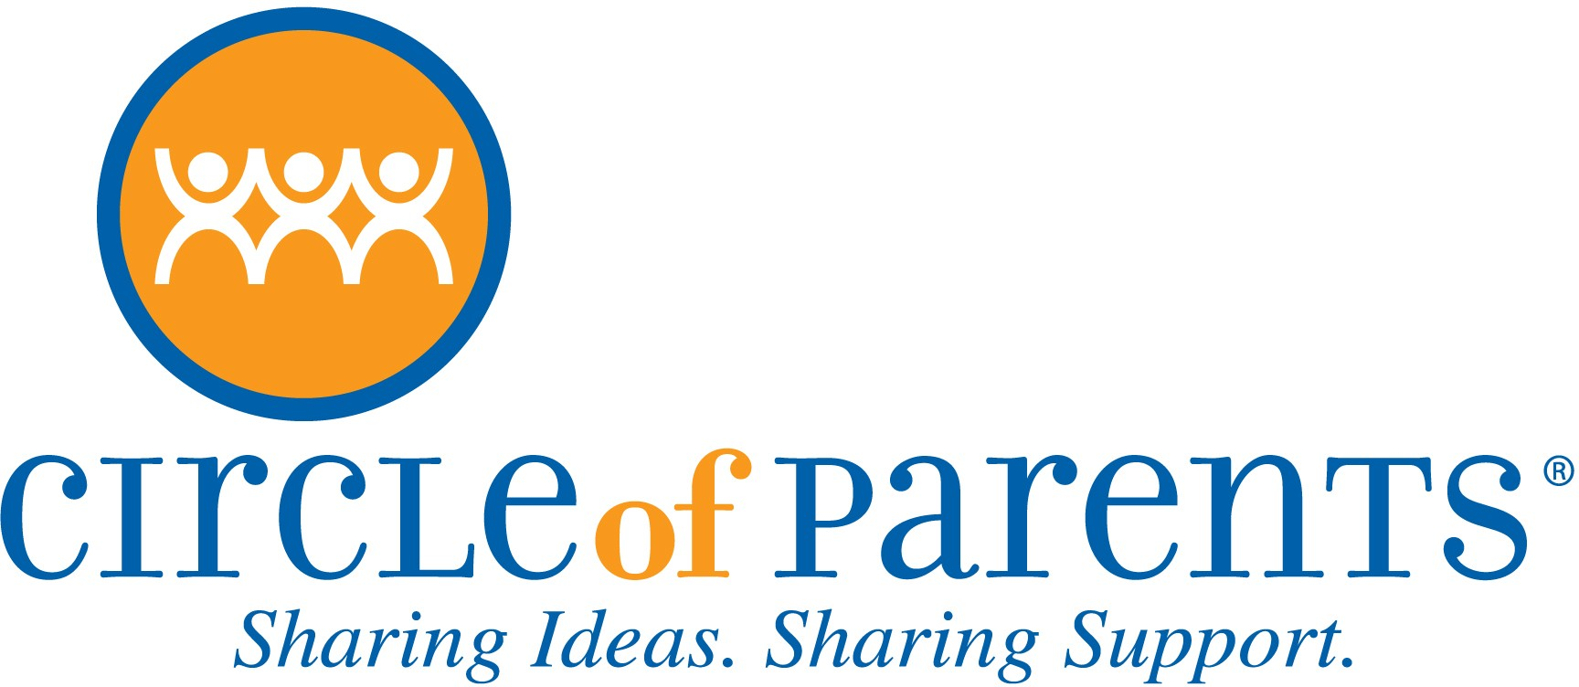
For more information contact: LaCrisha Rose, Network Facilitator Circle of Parents West Virginia
lacrisha@teamwv.org, 304-410-5888 Website: www.teamwv.org/circle-of-parents/

Circle of Parents Groups in West Virginia
The organizations and contacts listed below have been recently trained in the Circle of Parents model and are in the beginning phases of conducting active groups.

Organization and Region Served | Contact Person
Mercer Co Starting Points Family Resource Center  (A program of Child Protect of Mercer County) | Shiloh Woodard swoodard@mercerchildprotect.com
Partnership of African American Churches  (West Side Ward 4 Substance Abuse Prevention Coalition, Charleston) | Edna Green egreen@paac2.org
Step by Step  (Statewide support for Foster/Adoptive/Kinship Care) | Marissa Sanders sandersmarissawv@gmail.com
WV Healthy Kids and Families Coalition  (Charleston’s WestSide) | Shanequa Smith  sqsmith@mix.wvu.edu

The Circle of Parents State Network will conduct weekly virtual support groups on
Fridays at 10am beginning May 1st, 2020.
For registration details please contact LaCrisha Rose at lacrisha@teamwv.org
or by visiting the TEAM for WV Children website www.teamwv.org
or by clicking the following link: Virtual Circle of Parents

